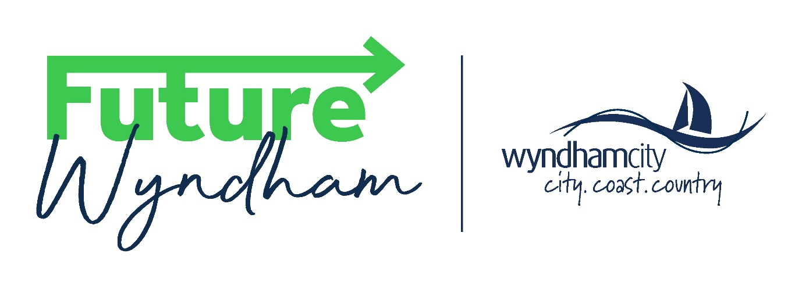

**Subject line: Invitation for First Nations community members to get involved in the Future Wyndham project**

Wyndham City Council is beginning a new and exciting project and we want you to come and yarn with us about it on Bunurong Land!

The Future Wyndham project will help the community update the [Community Vision](https://indd.adobe.com/view/20ea2c9b-df93-4e3f-b607-29b2222352b7), a long-term document that guides everything we do at Council. To find out more about the Future Wyndham project, [read our FAQ’s](https://theloop.wyndham.vic.gov.au/future-wyndham/future-wyndham-faqs).

To make sure we hear the voices of **Australian First Nations** people, we’d like to invite you to one of our Future Wyndham Workshops.

**We want to yarn with you about three important questions:**

* 1. Do you think our current Vision for Wyndham is still right?
  2. Should anything in the Vison be changed?
  3. What three things should Council focus on for the next four years?

**What do I need to know?**

* You only need to attend **one** workshop.
* Catering will be provided.
* A Welcome and Smoking Ceremony will be conducted before each workshop.
* You will receive a thank you gift for your time.
* First Nations and non-First Nations staff members will host the workshop.
* We can provide support for you to attend the workshop. Let us know what support you need when you register for the workshop.

**How do I register for a Workshop?**

You can register to attend **one** of the following workshops that will take place in Council Chambers at the Wyndham Civic Centre, 45 Princes Highway Werribee, on:

1. **Workshop 1 - Wednesday 31 July** 1.30pm arrival for Welcome and Smoking Ceremony, Workshop from: 2pm – 3.30pm
2. **Workshop 2 - Wednesday 31 July** 5.30pm arrival for Welcome and Smoking Ceremony, Workshop from: 6pm - 7.30pm.

You **must register** to attend a workshop via this [**online registration form on The Loop**](https://theloop.wyndham.vic.gov.au/future-wyndham/future-wyndham-register-attend-community-workshop-3)**.**

If you need help to register, or have a question you can:

* Email: [futurewyndham@wyndham.vic.gov.au](mailto:futurewyndham@wyndham.vic.gov.au)
* Call: 1300 023 411 and ask for Belinda Cliffe or Kate Imms.

We will send you email and text message reminders closer to the workshop.

Attendance numbers will be capped to ensure everyone’s voice is heard – sign up early so you don’t miss out!

**I can’t make it to a workshop.**

If you are unable to attend a workshop there are other opportunities to get involved including visiting us at one of our pop-ups happening across Wyndham, or you can provide feedback via our online survey. [**Go to The Loop**](https://theloop.wyndham.vic.gov.au/future-wyndham) to find out more.

**Feedback closes at 11:59PM, Sunday 25 August 2024.**